The human learning method of predicting the out-of-stock date

The human prediction method uses stock as the only variable, and it could be used on any subset of the data, no matter the data size or data type, with a stable error (lower than guess error).

According to the general rules, more stock means later out-of-stock date. And in our data, the variance of the products with stock 1 is too large, the safest prediction is the median of the out-of-stock date distribution.

One way to improve this method is using stock/total sold units as a new variable. In this case, the prediction could involve more case sold out before the median date.

Use the cold_product subset as an example.

Step 1: Based on the linear line, the stocks are split into [1,2],[3,7],[8,21] (because stock 1 and stock 2 are far away from the regression line, and the amount of stock 8 is more than stock 7). If the stock table is large, just use straight lines with different slope to cut the stocks into groups.

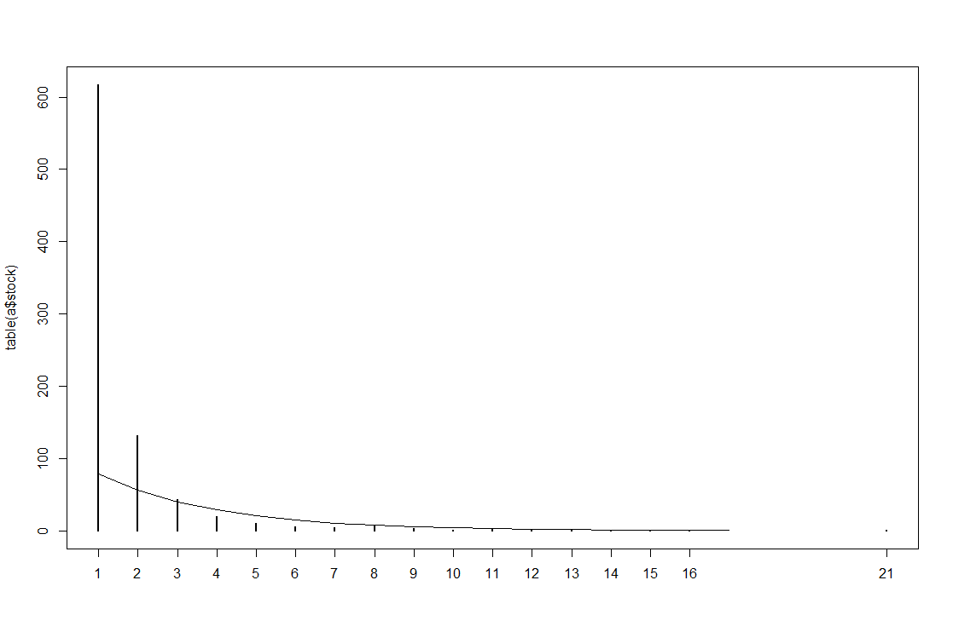

Step 2: Use the output from ts prediction to find several lowest point. The out of stock dates of the products with stock 1 or 2 are tend to distribute in the whole month evenly. Thus, the partial lowest point near the middle of the whole distribution will be the estimate date for stock==1 or 2 (let’s call it point 1). The last partial lowest point (cannot be the last day of this month) is the estimate date for the last subset of stock (let’s call it point 2). Then, put the subsets into the period between point 1 and 2 evenly or as a exp distribution.

Here’s some different ts result:

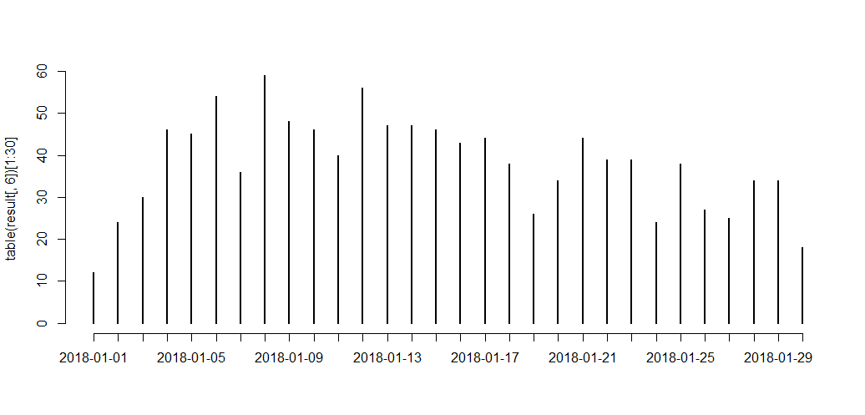

[1,2]->2018-1-19

[3,7]->2018-1-24

[8,21]-> 2018-1-27

Err: 81.866 (Err.guess:83.283)

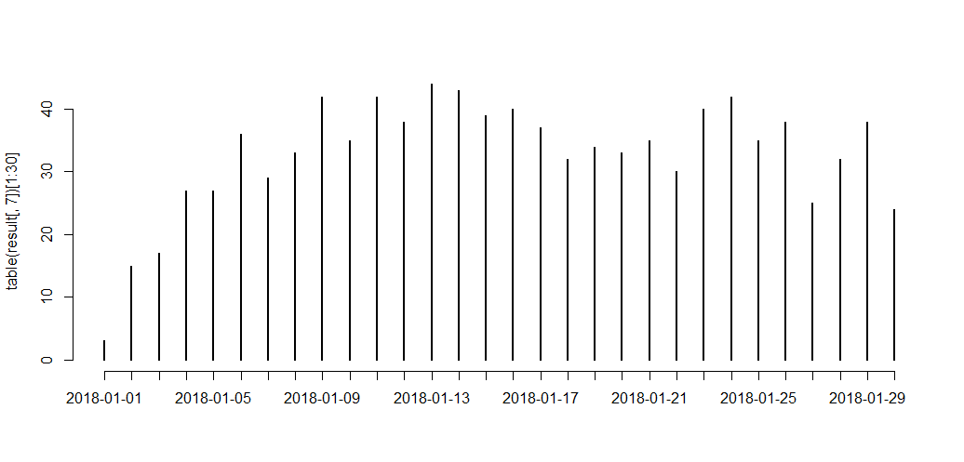

[1,2]->2018-1-18

[3,7]->2018-1-21

[8,21]-> 2018-1-27

Err: 81.786 (Err.guess:83.283)

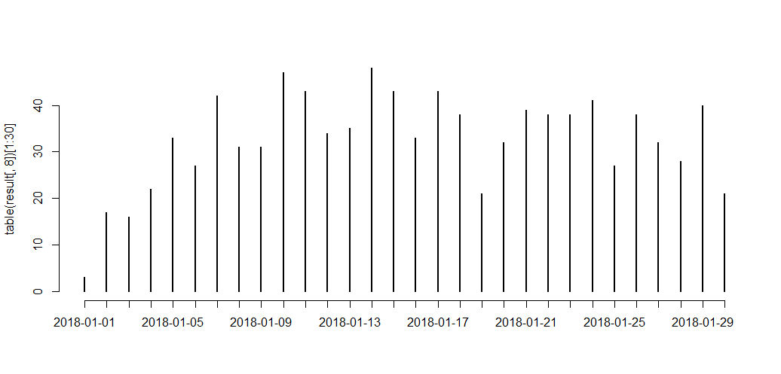

[1,2]->2018-1-19

[3,7]->2018-1-25

[8,21]-> 2018-1-28

Err: 81.841 (Err.guess:83.283)

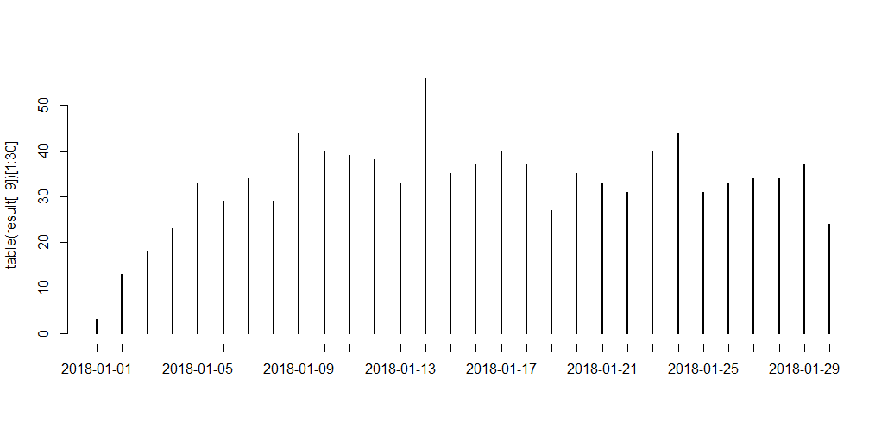

[1,2]->2018-1-19

[3,7]->2018-1-25

[8,21]-> 2018-1-30

Err: 81.939 (Err.guess:83.283)

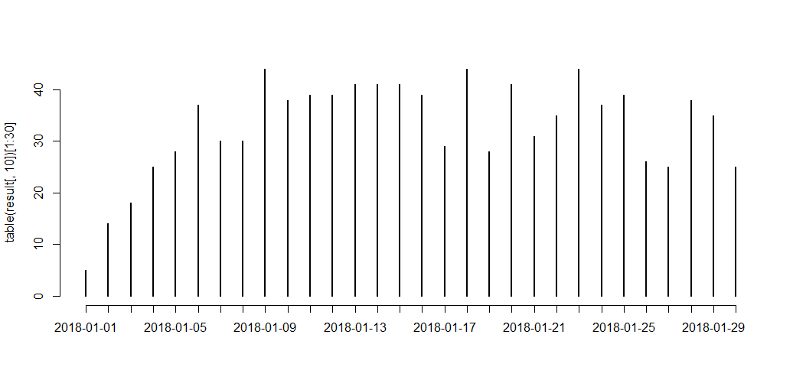

[1,2]-> 2018-1-17

[3,7]->2018-1-21

[8,21]-> 2018-1-27

Err: 81.688 (Err.guess:83.283)

By the true distribution of Jan_out_of_stock_data:

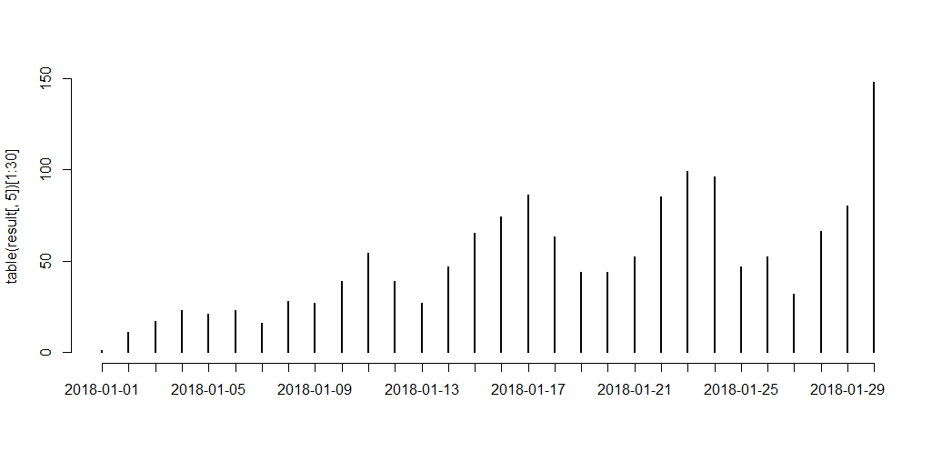

[1,2]-> 2018-1-19

[3,7]->2018-1-25

[8,21]-> 2018-1-27

Err: 81.847 (Err.guess:83.283)